Chapter 3, Problem 73.

Write the mesh-current equations for the circuit in Fig. 3.117.

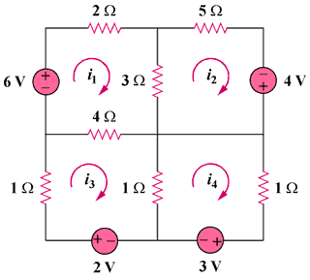

Figure 3.117
For Prob. 3.73.

